***It’s All About Timing!***

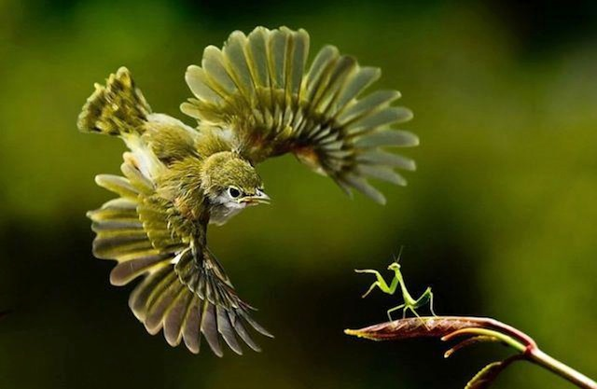 **36 PERFECTLY TIMED ANIMAL SHOTS**  Check out 36 perfectly timed animal shots. Taken with high precision but most of the*Image Credit:* 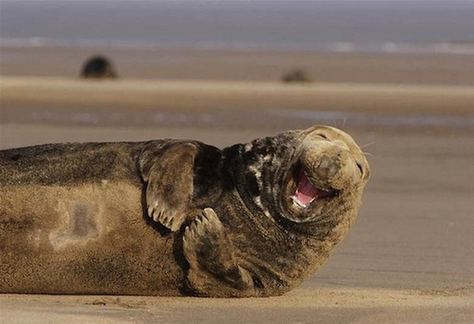 *Image Credit:* 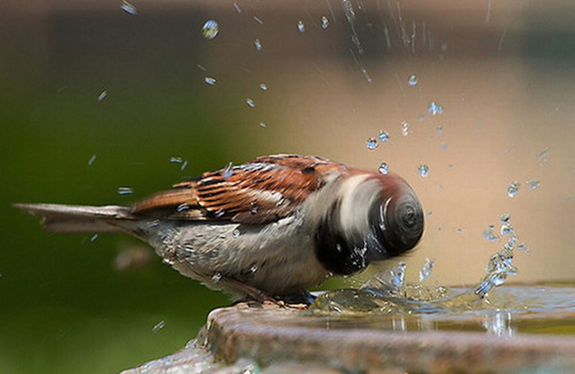 *Image Credit: >* 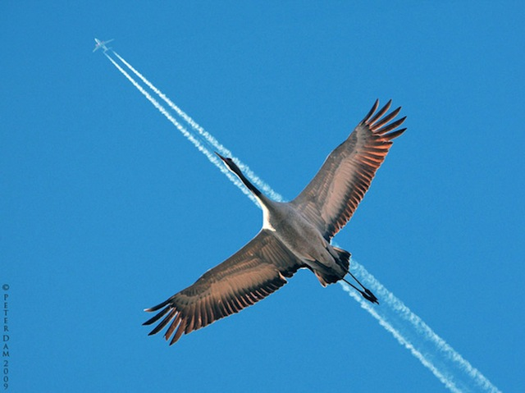 *Image Credit: Peter Dam* 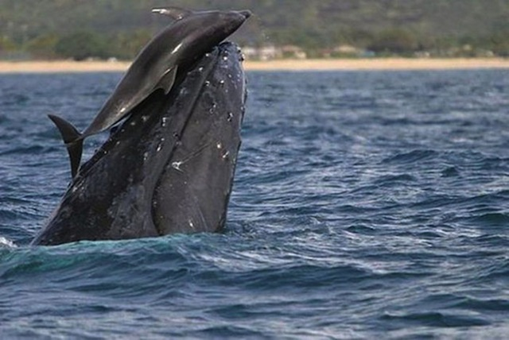  *Image Credit: Unknown* 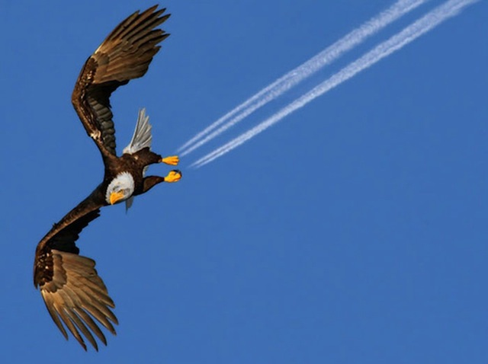 *Image Credit: Pam MullinsImage Credit: Unknown* 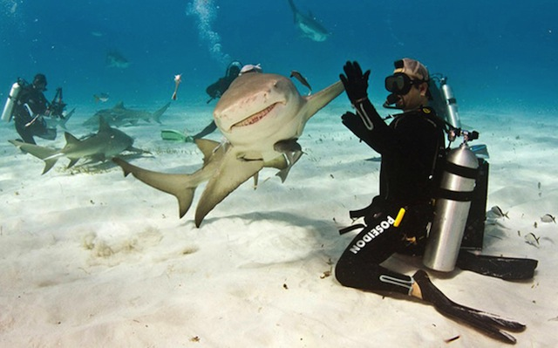 *Imag* 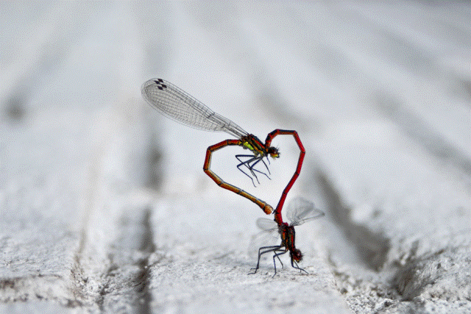*Image Credit:* 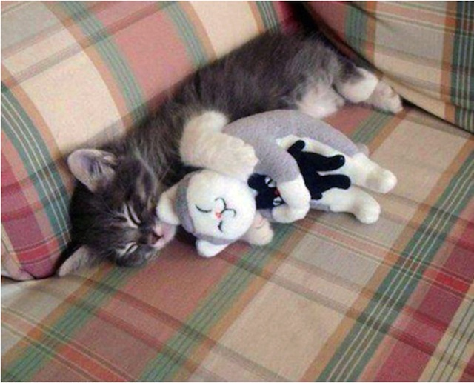 *Image Credit: Unknown* 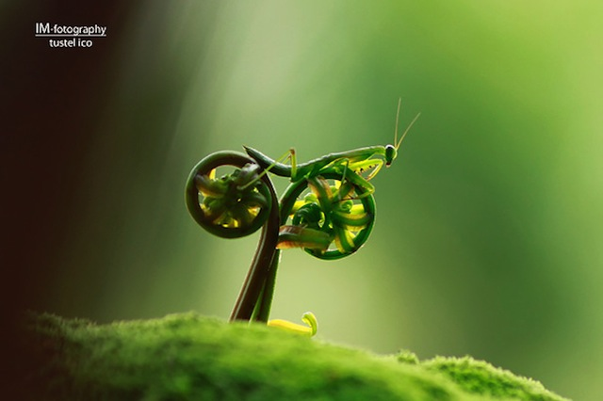  *Cano* 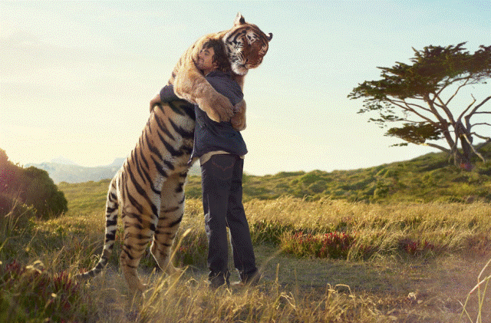 *Image Credit:*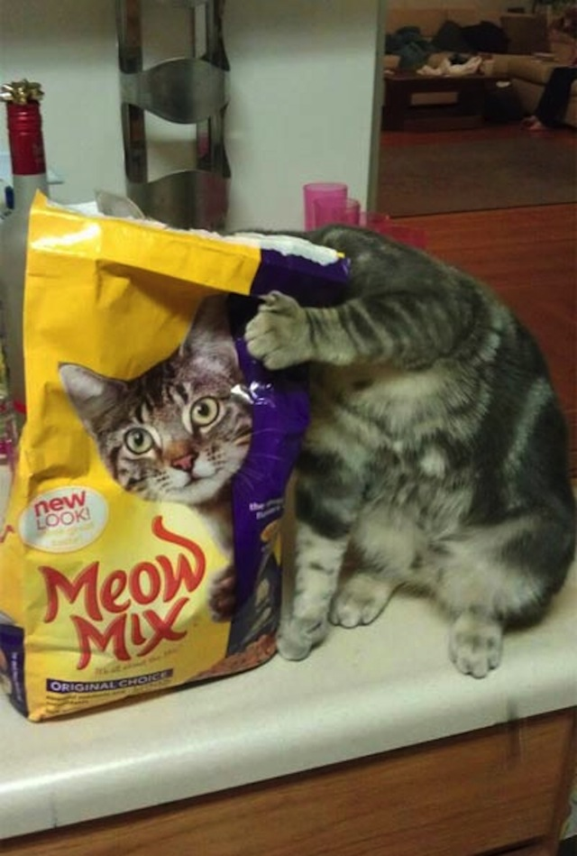 *Image Credit: Unknown* 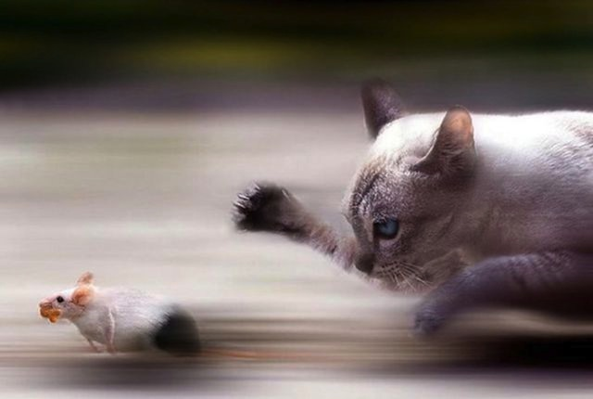 *Image Credit: Unknown* 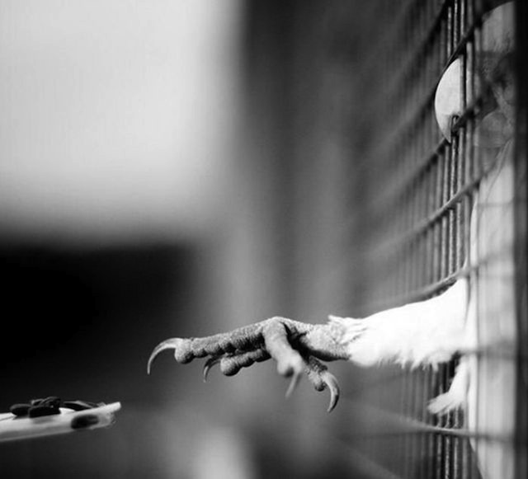 *Image Credit: Unknown* 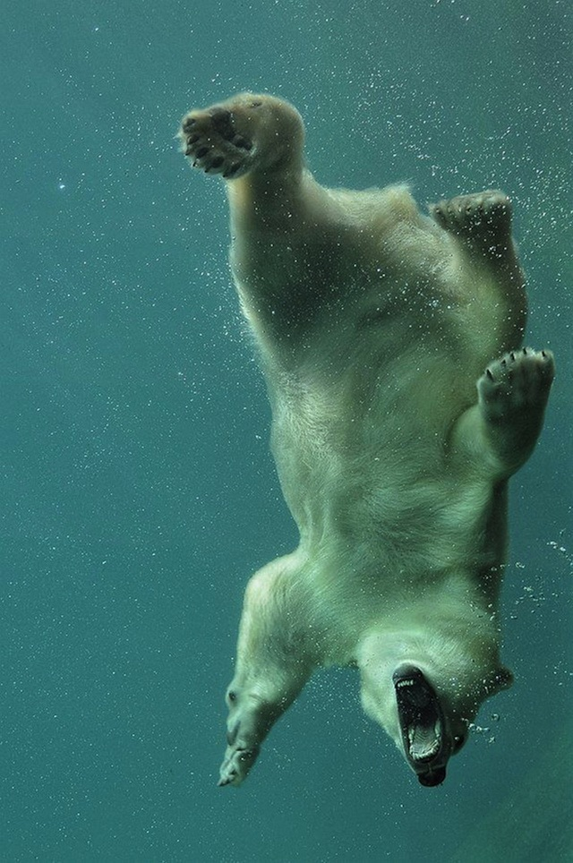 *Image Credit: Unknown* 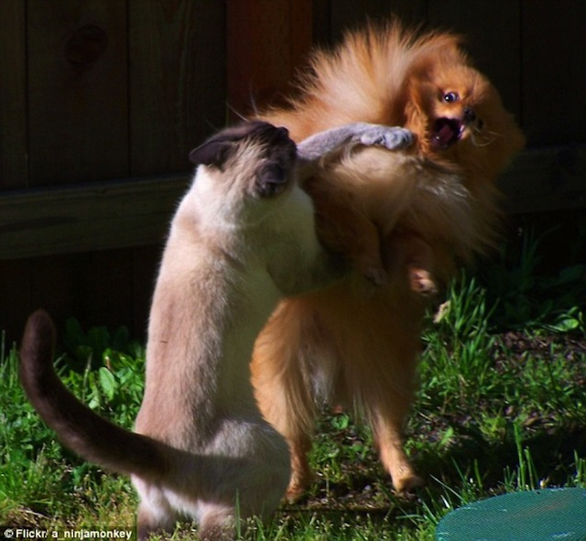 *Image Credit Flickr* 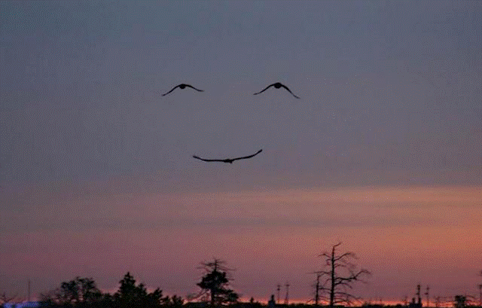 *Image Credit: Unknown* 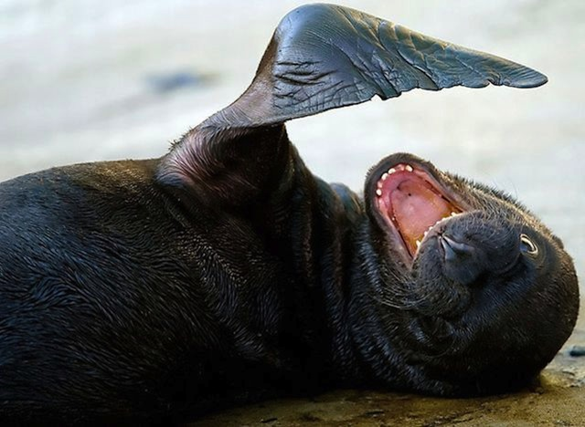 *Image Credit: Unknown* 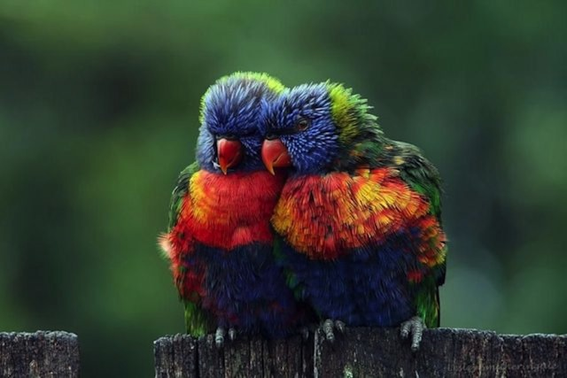 *Image Credit: Unknown* 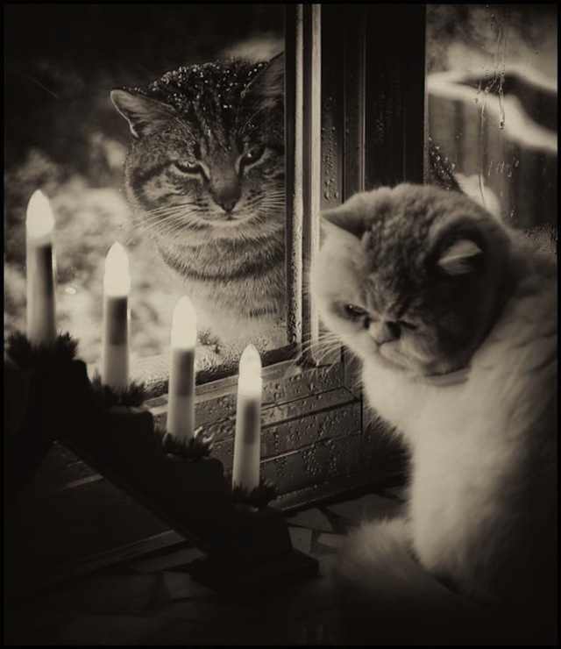 *Image Credit: Unknown* 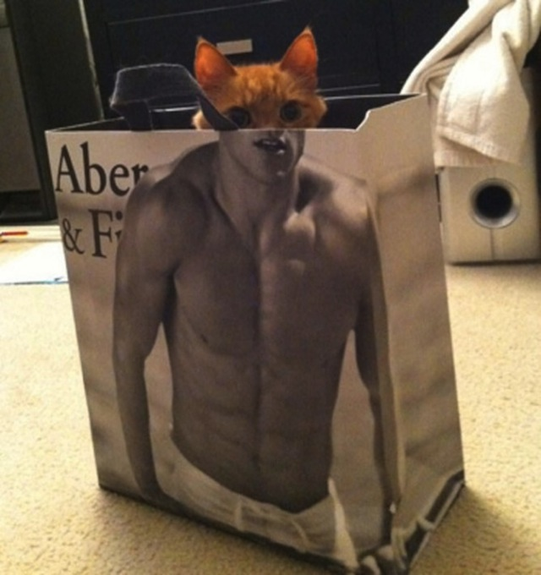 *Image Credit: Unknown*  *Image Image Credit: Unknown* 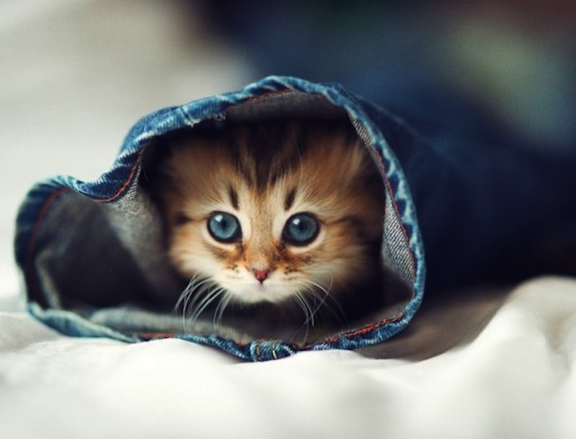 *Image Credit: Ben Terode* 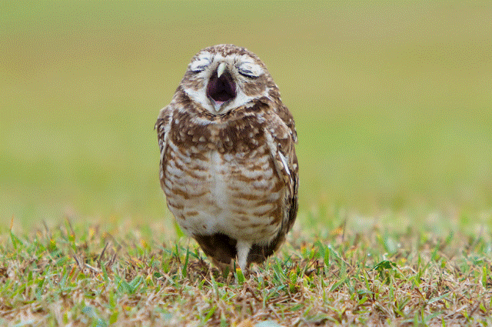 *Image Credit: Elena davidova* 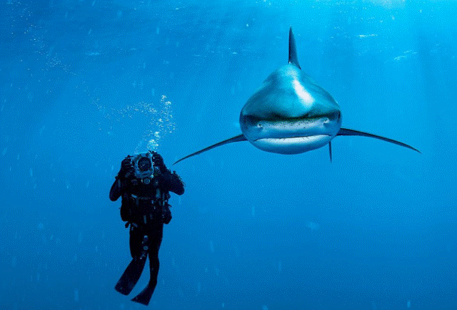 *Image Credit: Brian Skerry* 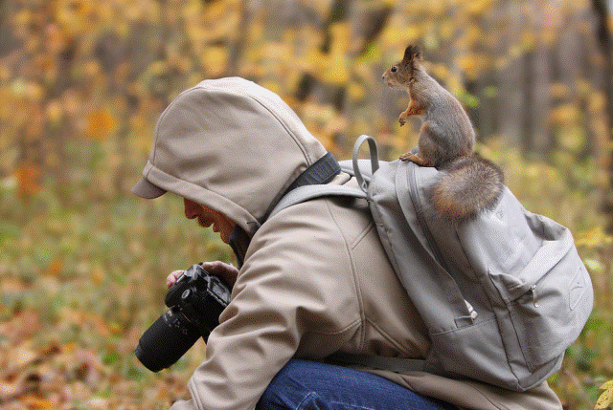 *Image Credit: Unknown*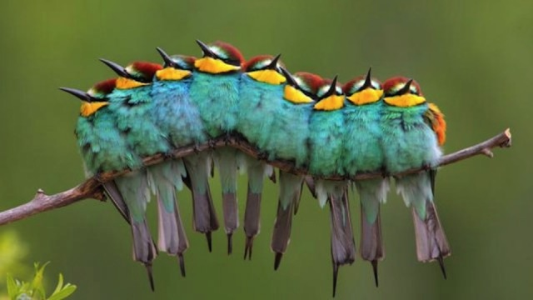 *Image Credit: José Luis Rodríguez*